1. Dashboard (Customisable & User role wise)
2. Lead
   1. Lead add (Button) Quick Lead
      1. Name\* text (done)
      2. Surname\* text (done)
      3. Gender
      4. Mobile Number only number (done)
      5. Email email text (any one compulsory) (done)
      6. State Drop Down. Default & custom by branch
      7. City\* Drop Down. Default & custom by branch (link with state)
      8. Area\* Drop Down & set area by branch & admin city wise (link with city)
      9. Address & Pin code area text
      10. Branch if multi branch user
      11. Department (Multimedia, Designing, College ) Drop Down & customize by branch & admin
      12. Course Package Radio Button (Package & Single) (Link with Department)
      13. Course (Link with course package) if course package not available than connect with department
      14. Campaign name (done)
      15. Chanel (done)
      16. Source (connected with channel) (done)
      17. Source Remarks (Connected with sources) (done)
      18. Priority (done)
      19. Status Drop Down. Default & custom by branch (link with sub status)
          1. New
          2. Follow up
          3. Urgent Follow up
          4. Walking
          5. Demo
          6. Enrolled
          7. Close
          8. Trash
      20. Sub Status (link with status) Drop Down with multi-selection
      21. Follow up Mode Drop Down
      22. Next follow up date (Link With Sub Status)
      23. Follow up remarks (Link With Sub Status)
      24. Remarks area text
   2. Bulk upload (CSV sheet) For Selected User role Only

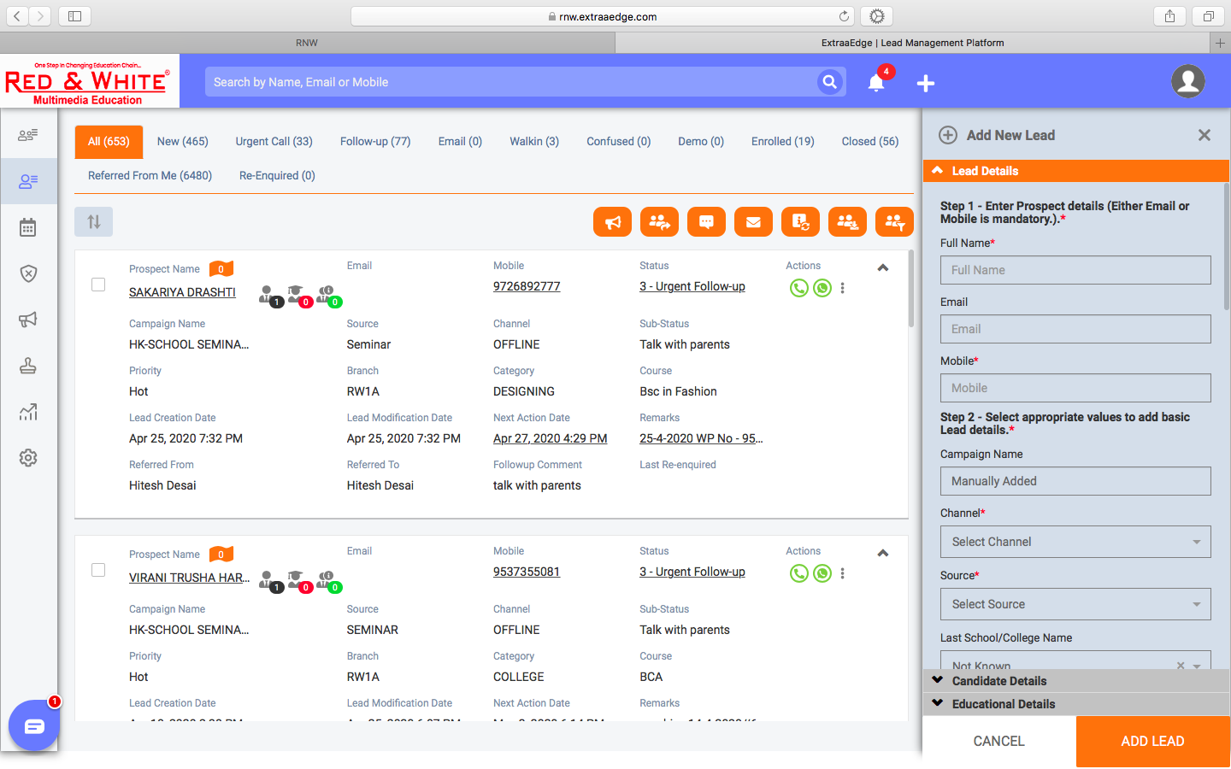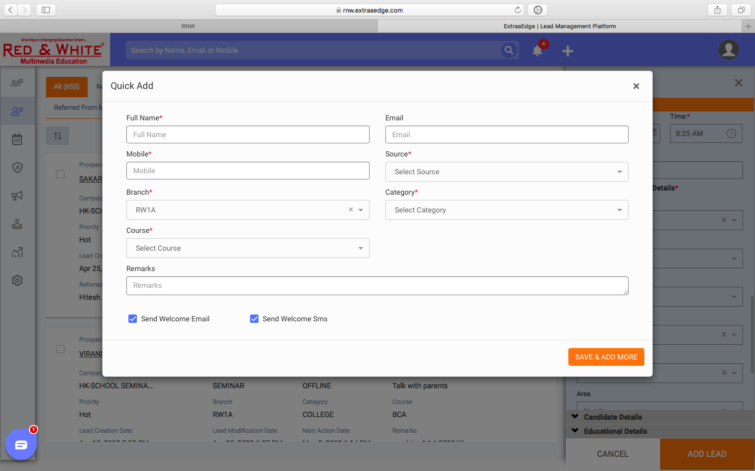 Quick Lead

Add Lead



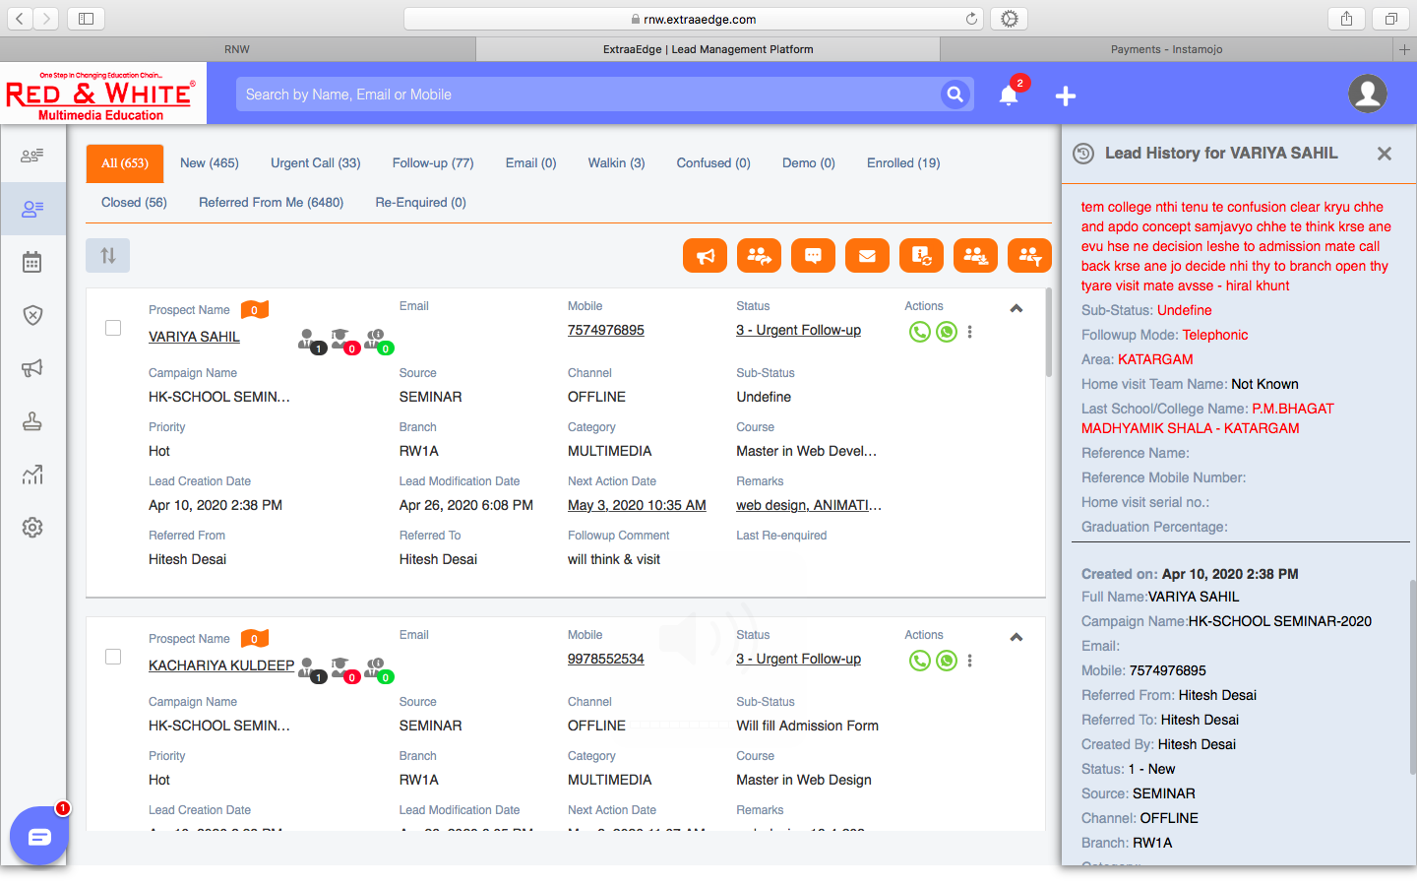

1. Old Inquiry (hide)
2. Demo
3. Admission
4. Task
5. Informative (All are user role wise visibility)
   1. Form
   2. FAQ
   3. Course Information
   4. T&C
   5. Seat Available
6. Property